**Project: Supernova**

Solar photovoltaic (PV) cells are constantly being improved and developed upon, being a renewable and sustainable source of energy. Generating electricity through solar cells involves it being put under direct sunlight, increasing its temperature over time; this contributes to the urban heat island effect, since its usage along the years would contribute a significant amount of heat especially in more developed area where there has been an increasing application of solar cells. Furthermore, the heat generated also lowers the efficiency of the cells. Figure 1 shows the efficiency curve of the PV solar cells.

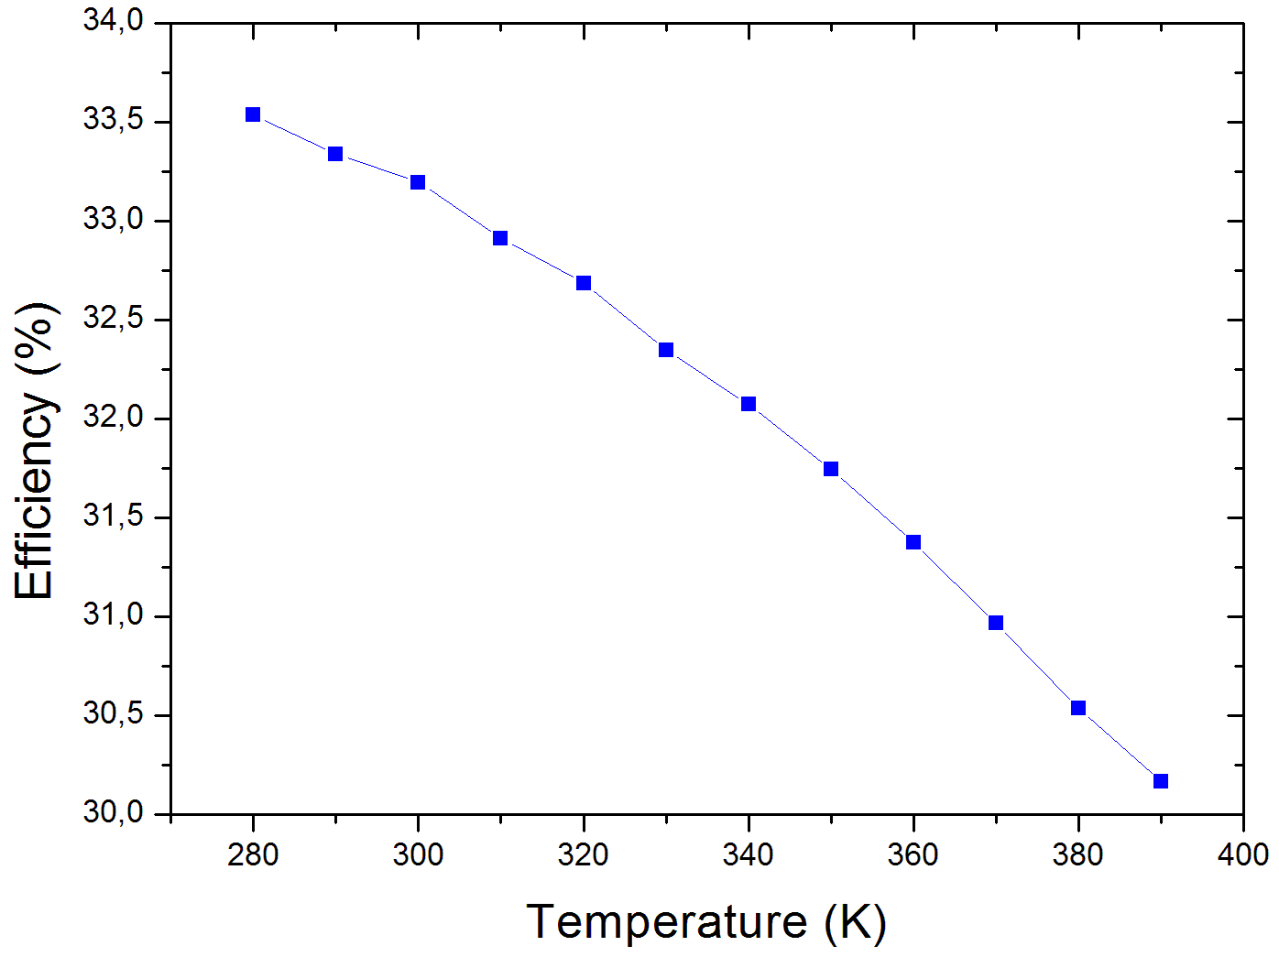

Figure 1: Graph of efficiency against temperature of a double-junction solar cell at a concentration of 1000 suns.

Thermoelectric cells can convert heat flux (difference in temperature) into electrical energy by utilizing the Seebeck effect. Hence, thermoelectric cells can be used to take advantage of the high temperature of the solar cells, lowering the temperature of the PV cells and increasing its efficiency while generating more electricity. This project therefore aims to increase the total electrical energy output of the solar cells while reducing the heat effect of solar PV cells by integrating thermoelectric cells.

In this project, we utilized Bismuth-Telluride (Bi­2Te3) thermoelectric cells acting as n-doped and p-doped semiconductors, creating a thermoelectric generator. They are put under the solar cells to fulfill two objectives: allowing the light energy to be absorbed by the solar PV cells, while at the same time ensuring that there is temperature difference between the two sides of the thermoelectric cells.

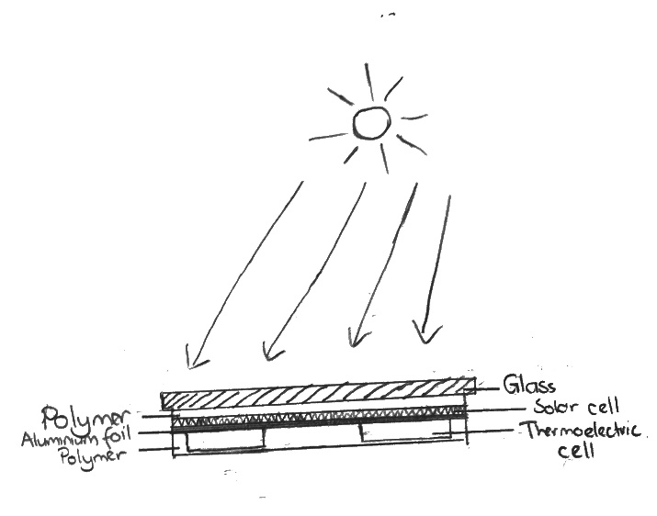

Figure 2: Lateral view of the prototype.

During the manufacturing of the thermo-photovoltaic cells, flux, which is a chemical-flowing agent, is applied during the soldering to prevent oxidation as the oxides will float rather than being stuck between the metals, increasing its efficiency. Encapsulating layers made of ethylene vinyl acetate are applied to prevent cracking of the solar cells, but a layer of aluminum foil is placed between the thermoelectric cells and the solar cell as to circumvent the thermal insulation of the polymer for a greater thermal difference.

Experiments are conducted on various times of the day with different weather conditions such as sunny and cloudy, with an average power output of 2.04Wh per cell. There are several improvements that can be made, including increasing the temperature difference between the surfaces of the thermoelectric generator by applying copper fins (i.e. heatsink) to increase electrical output­­ and preventing air bubbles from forming as can be seen in Figure 3b by either closing the gap between the thermoelectric cells or by using one big thermoelectric cell as air bubbles can increase the surface area and cause more heat loss.

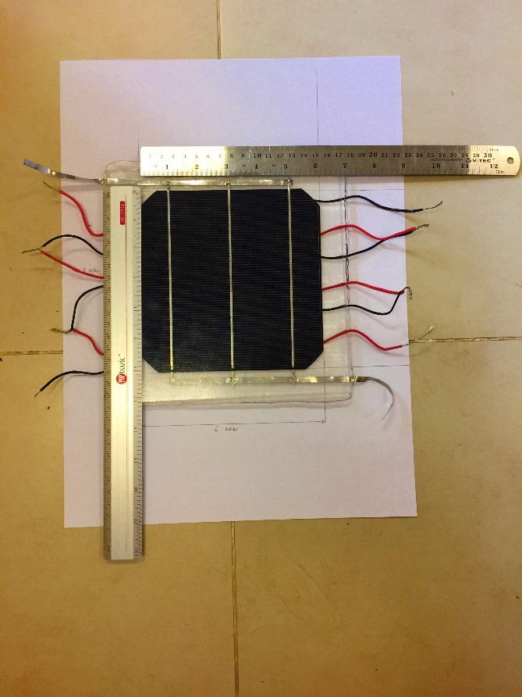 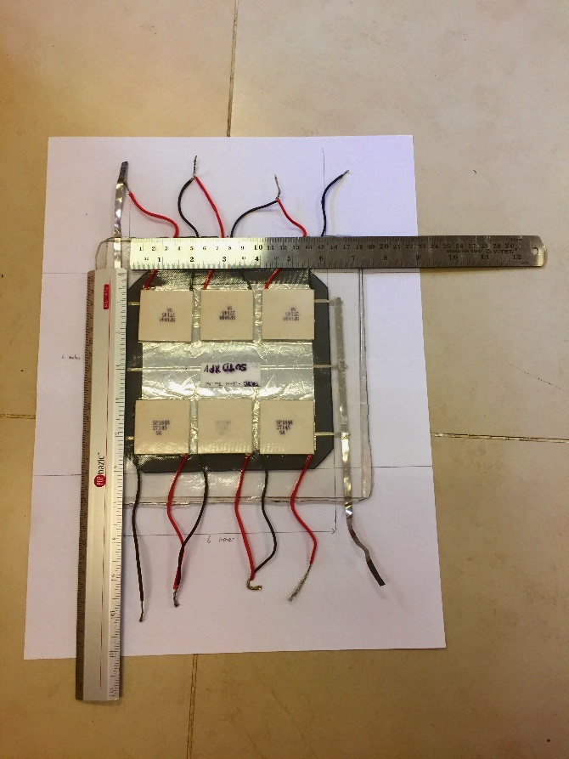

Figure 3a: Top view of the prototype. Figure 3b: Bottom view of the prototype.

Therefore, the relatively simple application of integrating thermoelectric cells into solar photovoltaic cells to form a thermoelectric photovoltaic hybrid power generator utilizes and slows down the urban heat island effect, while at the same time generating more electricity for people.